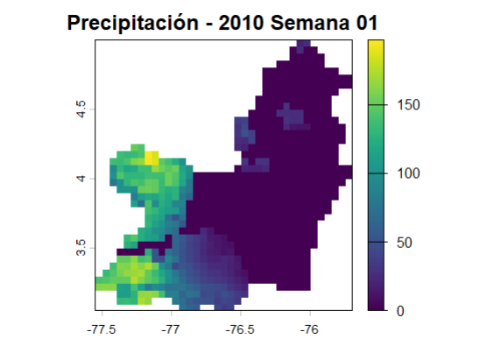

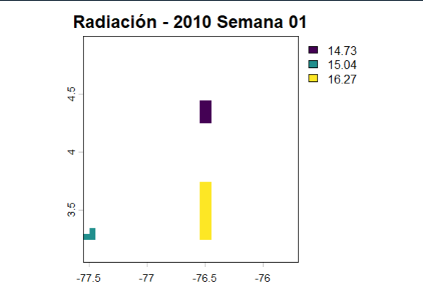

Temperatura

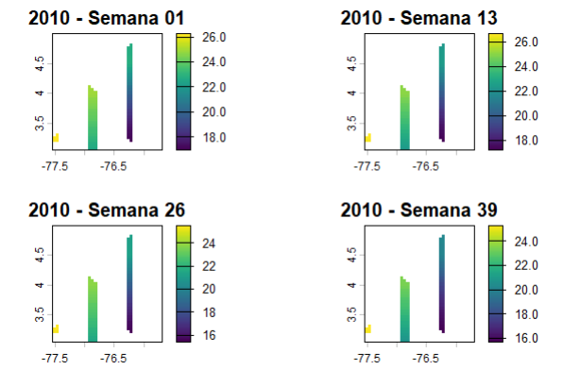

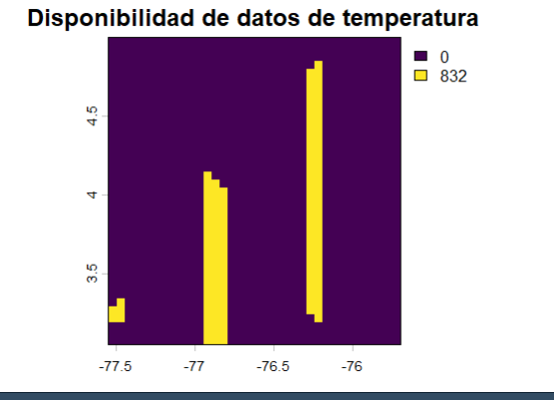

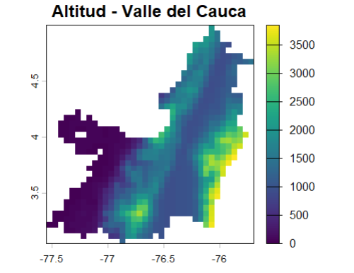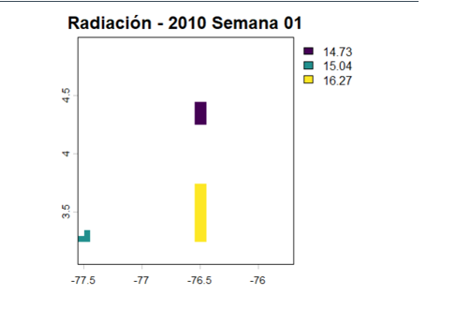

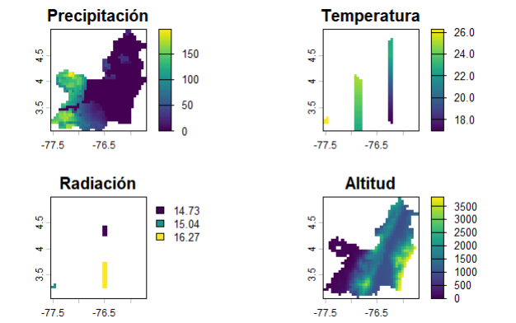

Temperatura :
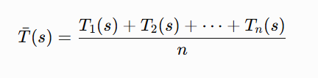

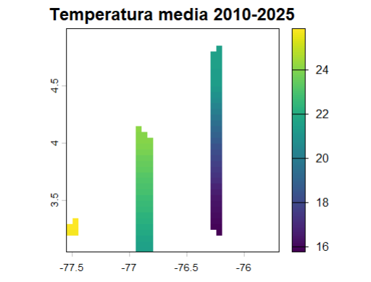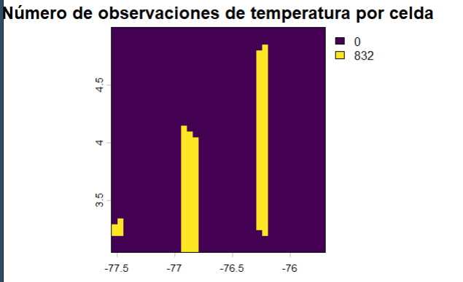

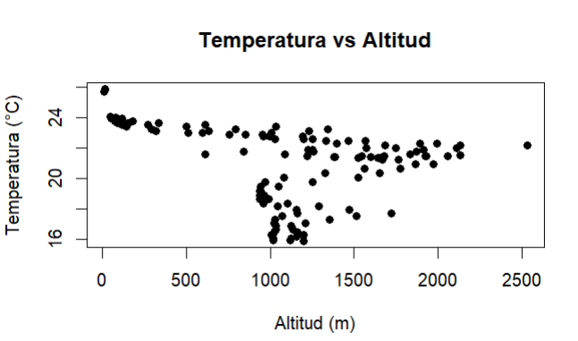

Correlación : -0.3329772

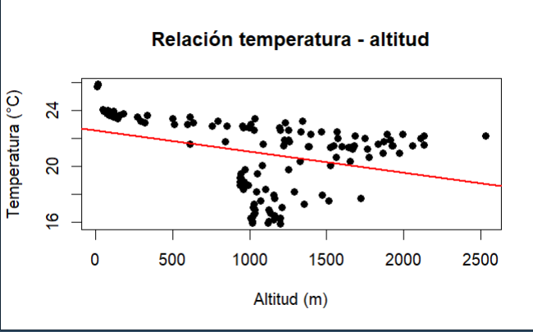

Temperatura con precipitaciones
radi

head(datos_temp)
lon lat temperatura altitud x_km y_km
1 -76.225 4.824999 21.50275 2130.915 40.00558 114.3497
3 -76.225 4.774999 21.47795 1927.391 40.00558 108.8210
4 -76.275 4.724999 21.45315 2056.899 34.45176 103.2923
5 -76.225 4.724999 21.45315 1680.207 40.00558 103.2923
6 -76.275 4.674999 21.42835 1931.551 34.45176 97.7636
7 -76.225 4.674999 21.42835 1546.882 40.00558 97.7636

Matriz vecindad
1 3 4 5 6
1 0.00 5.53 12.37 11.06 17.49
3 5.53 0.00 7.84 5.53 12.37
4 12.37 7.84 0.00 5.55 5.53
5 11.06 5.53 5.55 0.00 7.84
6 17.49 12.37 5.53 7.84 0.00

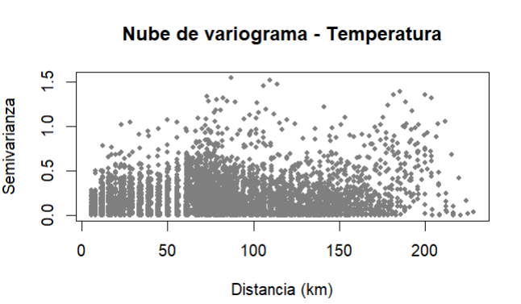
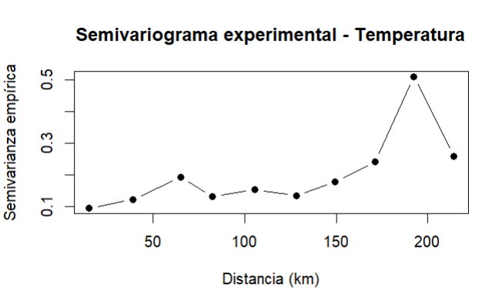

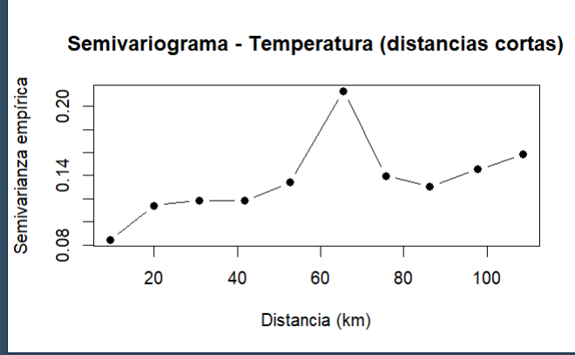

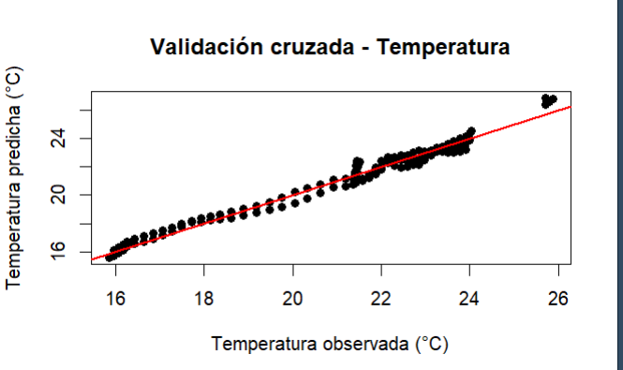

nugget sill phi rango_practico_km
0.0632616 0.1613848 33.5352170 100.6056510

>

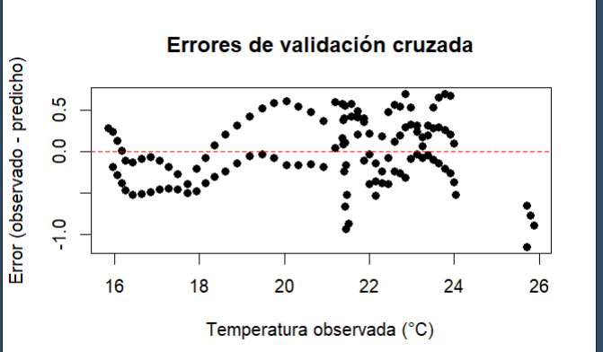

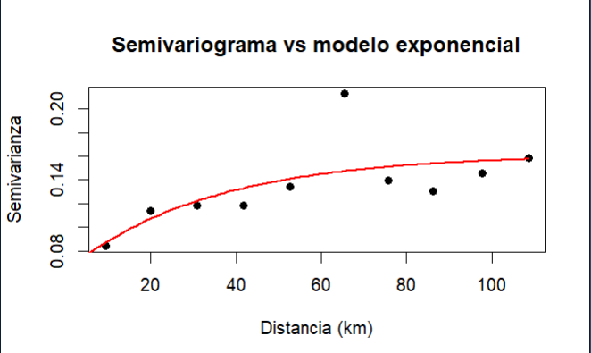

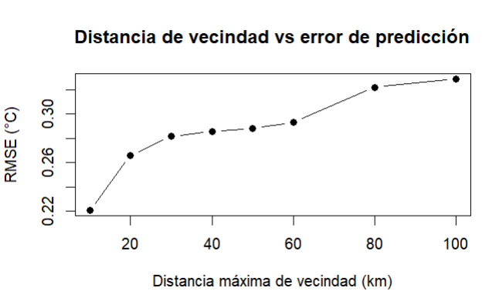

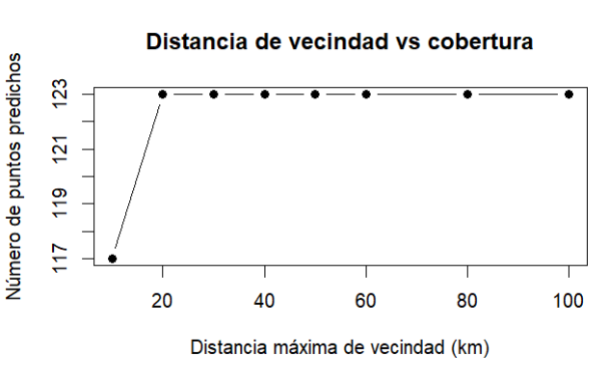

1 3 4 5 6
1 0.00 5.53 12.37 11.06 17.49
3 5.53 0.00 7.84 5.53 12.37
4 12.37 7.84 0.00 5.55 5.53
5 11.06 5.53 5.55 0.00 7.84
6 17.49 12.37 5.53 7.84 0.00

